Lab 07 – Configuring HSRP
Topology
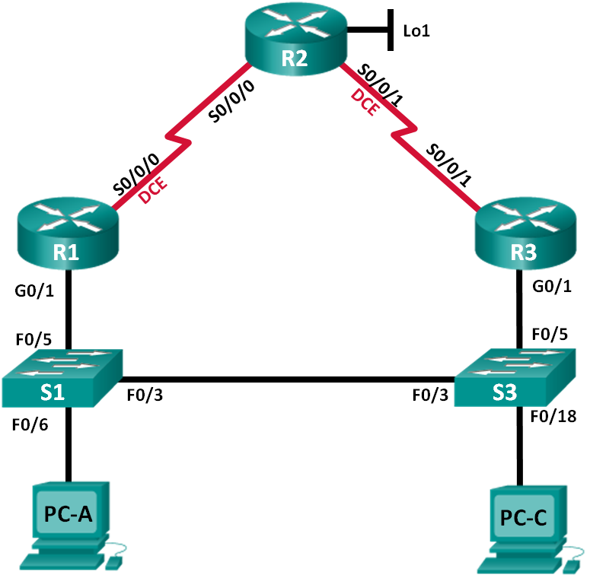

Device | Interface | IP Address | Subnet Mask | Default Gateway
R1 | G0/1 | 192.168.1.1 | 255.255.255.0 | N/A
 | S0/0/0 (DCE) | 10.1.1.1 | 255.255.255.252 | N/A
R2 | S0/0/0 | 10.1.1.2 | 255.255.255.252 | N/A
 | S0/0/1 (DCE) | 10.2.2.2 | 255.255.255.252 | N/A
 | Lo1 | 209.165.200.225 | 255.255.255.224 | N/A
R3 | G0/1 | 192.168.1.3 | 255.255.255.0 | N/A
 | S0/0/1 | 10.2.2.1 | 255.255.255.252 | N/A
S1 | VLAN 1 | 192.168.1.11 | 255.255.255.0 | 192.168.1.1
S3 | VLAN 1 | 192.168.1.13 | 255.255.255.0 | 192.168.1.3
PC-A | NIC | 192.168.1.31 | 255.255.255.0 | 192.168.1.1
PC-C | NIC | 192.168.1.33 | 255.255.255.0 | 192.168.1.3
Addressing Table

Objectives
Part 1: Build the Network and Verify Connectivity.
Part 2: Configure First Hop Redundancy using HSRP.
Background / Scenario
Spanning tree provides loop-free redundancy between switches within a LAN. However, it does not provide redundant default gateways for end-user devices within the network if one of the routers fails. First Hop Redundancy Protocols (FHRPs) provide redundant default gateways for end devices with no end-user configuration necessary. In this lab, you will configure Cisco’s Hot Standby Routing Protocol (HSRP), a kind of First Hop Redundancy Protocol (FHRP).

Part 1: Build the Network and Verify Connectivity
Set up the network topology and configure basic settings, such as the interface IP addresses, static routing, device access, and passwords.

Step 1: Cable the network as shown in the topology.
Attach the devices as shown in the topology diagram and cable as necessary.

Step 2: Configure PC hosts.
Step 3: Initialize and reload the routers and switches as necessary. Step 4: Configure basic settings and interface addresses.
- Also, set the clock rate to 128000 for all DCE serial interfaces.
- Copy the running configuration to the startup configuration.

Step 5: Configure basic settings for each switch.
- Also, configure IP addresses for the switches as listed in the Addressing Table.
- Configure the default gateway on each switch.
- Copy the running configuration to the startup configuration.

Step 6: Verify connectivity between PC-A and PC-C.
Note: To successfully ping between PCs, you may need to disable the PC firewall. This is only relevant if you are using physical hardware.

Step 7: Configure routing.
- Configure RIP v2, OSPF v2, or EIGRP on all routers. Add all the networks, except 209.165.200.224/27, into the Routing process.
- Configure a default route on R2 using Lo1 as the exit interface to 209.165.200.224/27 network.
- On R2, use the following commands to redistribute the default route into the RIP/OSPF/EIGRP process.
R2(config)# router rip/ospf/eigrp …
R2(config-router)# default-information originate

Step 8: Verify connectivity.

Part 2: Configure First Hop Redundancy Using HSRP
Even though the topology has been designed with some redundancy (two routers and two switches on the same LAN network), PC-A and PC-C are configured with only one gateway address. PC-A is using R1 and PC-C is using R3. If either of these routers or the interfaces on the routers went down, the PC could lose its connection to the Internet.
In Part 2, you will test how the network behaves before and after configuring HSRP. To do this, you will determine the path packets take to the loopback address on R2.

Step 1: Determine the path for Internet traffic for PC-A and PC-C.
- From a command prompt on PC-A, issue a tracert command to the 209.165.200.225 loopback address of R2.

C:\> tracert 209.165.200.225
Tracing route to 209.165.200.225 over a maximum of 30 hops

1 | 1 ms | 1 ms | 1 ms 192.168.1.1
2 | 13 ms | 13 ms | 13 ms 209.165.200.225

Trace complete.
What path did the packets take from PC-A to 209.165.200.225?

- From a command prompt on PC-C, issue a tracert command to the 209.165.200.225 loopback address of R2.
What path did the packets take from PC-C to 209.165.200.225?

Step 2: Start a ping session on PC-A, and break the connection between S1 and R1.
- From a command prompt on PC-A, issue a ping –t command to the 209.165.200.225 address on R2. Make sure you leave the command prompt window open.
Note: The pings continue until you press Ctrl+C, or until you close the command prompt window.

C:\> ping –t 209.165.200.225
Pinging 209.165.200.225 with 32 bytes of data:
Reply from 209.165.200.225: bytes=32 time=9ms TTL=254 Reply from 209.165.200.225: bytes=32 time=9ms TTL=254 Reply from 209.165.200.225: bytes=32 time=9ms TTL=254
<output omitted>
- As the ping continues, disconnect the Ethernet cable from F0/5 on S1. Alternatively, you can shut down the S1 F0/5 interface, which creates the same result.
What happened to the ping traffic?

- What would be the results if you repeat Steps 2a and 2b on PC-C and S3?

- Reconnect the Ethernet cables to F0/5 or enable the F0/5 interface on S1 and S3, respectively. Re-issue pings to 209.165.200.225 from both PC-A and PC-C to ensure connectivity is re-established.

Step 3: Configure HSRP on R1 and R3.
In this step, you will configure HSRP and change the default gateway address on PC-A, PC-C, S1, and S2 to the virtual IP address for HSRP. R1 becomes the active router via the configuration of the HSRP priority command.
- Configure HSRP on R1.
R1(config)# interface g0/1
R1(config-if)# standby version 2
R1(config-if)# standby 1 ip 192.168.1.254
R1(config-if)# standby 1 priority 150
R1(config-if)# standby 1 preempt
- Configure HSRP on R3.
R3(config)# interface g0/1
R3(config-if)# standby version 2
R3(config-if)# standby 1 ip 192.168.1.254
- Verify HSRP by issuing the show standby command on R1 and R3.
R1# show standby
GigabitEthernet0/1 - Group 1 (version 2) State is Active
4 state changes, last state change 00:00:30 Virtual IP address is 192.168.1.254
Active virtual MAC address is 0000.0c9f.f001
Local virtual MAC address is 0000.0c9f.f001 (v2 default) Hello time 3 sec, hold time 10 sec
Next hello sent in 1.696 secs Preemption enabled
Active router is local
Standby router is 192.168.1.3, priority 100 (expires in 11.120 sec) Priority 150 (configured 150)
Group name is "hsrp-Gi0/1-1" (default)

R3# show standby
GigabitEthernet0/1 - Group 1 (version 2) State is Standby
4 state changes, last state change 00:02:29 Virtual IP address is 192.168.1.254
Active virtual MAC address is 0000.0c9f.f001
Local virtual MAC address is 0000.0c9f.f001 (v2 default) Hello time 3 sec, hold time 10 sec
Next hello sent in 0.720 secs Preemption disabled
Active router is 192.168.1.1, priority 150 (expires in 10.128 sec) MAC address is d48c.b5ce.a0c1
Standby router is local Priority 100 (default 100)
Group name is "hsrp-Gi0/1-1" (default)
Using the output shown above, answer the following questions: Which router is the active router?
What is the MAC address for the virtual IP address?
What is the IP address and priority of the standby router?

- Use the show standby brief command on R1 and R3 to view an HSRP status summary. Sample output is shown below.

R1# show standby brief

Interface | P  |  Grp Pri P | indicates configured  State Active | to | preempt.  Standby | Virtual IP
Gi0/1 | 1 150 P | Active local |  | 192.168.1.3 | 192.168.1.254

R3# show standby brief
P indicates configured to preempt.
|
Interface Grp Pri P State Active Standby Virtual IP Gi0/1 1 100 Standby 192.168.1.1 local 192.168.1.254
- Change the default gateway address for PC-A, PC-C, S1, and S3. Which address should you use?
- Verify the new settings. Issue a ping from both PC-A and PC-C to the loopback address of R2. Are the pings successful?

Step 4: Start a ping session on PC-A and break the connection between the switch and the Active HSRP router (R1).
- From a command prompt on PC-A, issue a ping –t command to the 209.165.200.225 address on R2. Ensure that you leave the command prompt window open.
- As the ping continues, disconnect the Ethernet cable from F0/5 on S1 or shut down the F0/5 interface. What happened to the ping traffic?

Step 5: Verify HSRP settings on R1 and R3.
- Issue the show standby brief command on R1 and R3.
Which router is the active router? Reconnect the cable between the switch and the router or enable interface F0/5. Now, which router is the active router? Explain.

Step 6: Change HSRP priorities.
- Change the HSRP priority to 200 on R3. Which is the active router?
- Issue the command to change the active router to R3 without changing the priority. What command did you use?

- Use a show command to verify that R3 is the active router.
Reflection
Why would there be a need for redundancy in a LAN?

