Lab 3: Configuring Multi-Area OSPFv2
Topology
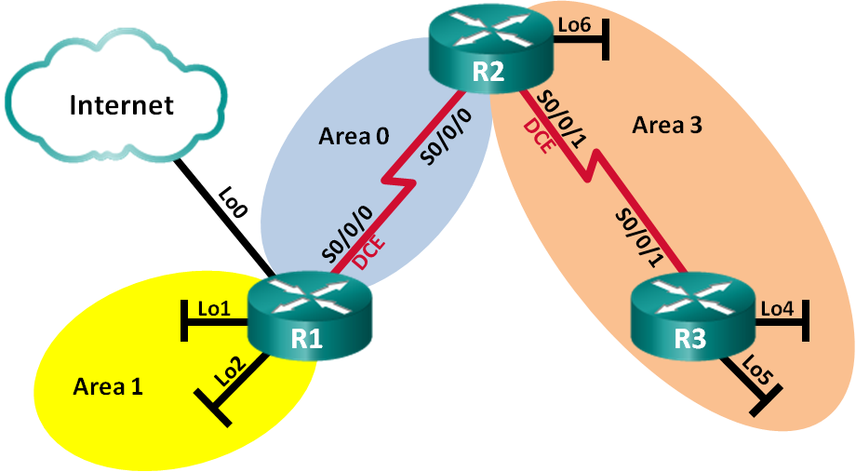
Addressing Table
Device | Interface | IP Address | Subnet Mask
R1 | Lo0 | 209.165.200.225 | 255.255.255.252
 | Lo1 | 192.168.1.1 | 255.255.255.0
 | Lo2 | 192.168.2.1 | 255.255.255.0
 | S0/0/0 (DCE) | 192.168.12.1 | 255.255.255.252
R2 | Lo6 | 192.168.6.1 | 255.255.255.0
 | S0/0/0 | 192.168.12.2 | 255.255.255.252
 | S0/0/1 (DCE) | 192.168.23.1 | 255.255.255.252
R3 | Lo4 | 192.168.4.1 | 255.255.255.0
 | Lo5 | 192.168.5.1 | 255.255.255.0
 | S0/0/1 | 192.168.23.2 | 255.255.255.252
Objectives
- Build the network and configure basic device settings.
- Configure a multi-area OSPFv2 Network
Background / Scenario
To make OSPF more efficient and scalable, OSPF supports two-level hierarchical routing using the concept of areas. An OSPF area is a group of routers sharing the same link-state information in their link-state databases (LSDBs). When a large OSPF network is divided into smaller areas, it is called multi-area OSPF. Multi-area OSPF is useful in larger network deployments to reduce processing and memory overhead.
In the lab, you will configure a multi-area OSPFv2 network.

Part 1: Build the Network and Configure Basic Device Settings
In this part, you will set up the network topology and configure basic settings on the routers.
Step 1: Cable the network as shown in the topology.
You can use either physical hardware, or you can use Packet Tracer. If you use Packet Tracer, use the same routers as you did in Lab #2 (specifically, the 1941 devices). You will also need to install HWIC-2T wide-area modules into the routers as you did before. Be sure to install the wide-area modules into Slot #0 so the interface names are consistent with the diagram above.
Step 2: Initialize and reload the routers as necessary.
This step is not necessary for Packet Tracer simulated devices.
Step 3: Configure basic settings for each router.
As you did in Lab #2, configure the “basic settings” on each router so they have a common base configuration and access passwords. Configure console access, but do not configure remote access via Telnet or SSH.
Step 4: Configure network interfaces.
Configure the network interfaces as shown in the addressing table above. Use 128000 bps for the DCE clocks.
To configure the loopback addresses, just specify their names as “Lo0”, “Lo1”, etc., when using the interface command. The loopback addresses simulate Ethernet networks. They allow us to create a model with many networks without the inconvenience of specifying (and configuring) additional devices.
Step 5: Verify Layer 3 connectivity.
Use the show ip interface brief command to verify that the IP addressing is correct and that the interfaces are active. Verify that each router can ping its neighbor’s serial interface.

Part 2: Configure a Multi-Area OSPFv2 Network
In Part 2, you will configure a multi-area OSPFv2 network with a process ID of 1. All LAN loopback interfaces should be passive.
  - Identify the OSPF router types in the topology.
Identify the Backbone router(s). Identify the Autonomous System Boundary Router(s) (ASBR). Identify the Area Border Router(s) (ABR). Identify the Internal router(s).
  - Configure OSPF on R1.
    - Configure a router ID of 1.1.1.1 with OSPF process ID of 1.
    - Add the networks for R1 to OSPF.
R1(config-router)# network 192.168.1.0 0.0.0.255 area 1
R1(config-router)# network 192.168.2.0 0.0.0.255 area 1
R1(config-router)# network 192.168.12.0 0.0.0.3 area 0
    - Set LAN loopback interfaces, Lo1 and Lo2, as passive.
    - Create a default route to the Internet using exit interface Lo0.
Note: You may see the “%Default route without gateway, if not a point-to-point interface, may impact performance” message. This is normal behavior if using a Loopback interface to simulate a default route.
    - Configure OSPF to propagate the routes throughout the OSPF areas.
  - Configure OSPF on R2.
    - Configure a router ID of 2.2.2.2 with OSPF process ID of 1.
    - Add the networks for R2 to OSPF. Add the networks to the correct area. What commands did you use?
    - Set all LAN loopback interfaces as passive. What commands did you use?
  - Configure OSPF on R3.
    - Configure a router ID of 3.3.3.3 with OSPF process ID of 1.
    - Add the networks for R3 to OSPF. Write the commands used in the space below. What commands did you use?
    - Set all LAN loopback interfaces as passive. What commands did you use?
  - Verify that OSPF settings are correct and adjacencies have been established between routers.
    - Issue the show ip protocols command to verify OSPF settings on each router. Use this command to identify the OSPF router types and to determine the networks assigned to each area.
What is the OSPF router type for each router?
    - Issue the show ip ospf neighbor command to verify that OSPF adjacencies have been established between routers.
    - Issue the show ip ospf interface brief command to display a summary of interface route costs.
Reflection
What are the three advantages of designing a network with multi-area OSPF?
Submission
Submit your Packet Tracer model along with a document that gives the answers to the questions to Canvas.

