CIS 1152 - Lab #5 Form Handling and States
S. Ruegsegger
Modified with permission by Peter Chapin

Objective
This lab will focus on presenting and handling forms to a user. As presented in class, you can put the form and response in one file (a.k.a. MVC -- my favorite method); or you can separate them into multiple (two) script files. You will also need to make sticky forms.
Additionally, you need to use STATE variables in this assignment to handle the app flow. Note: do not use PHP SESSIONS. We will do that later. For now, please, just use HIDDENs. Hint: use the submit buttons as your STATE variables.

Task 1: Guess my number
Student skill: read in user input value from a web form; create and keep track of application state.
This is a classic; a game that I often use when I teach myself a new language. Have the computer create a random number (not hardcoded) but within a known range. Then, have a small interface form for the user to enter guesses. Your program simply responds to the user with “higher” or “lower.” Be sure to congratulate the user if they guess correctly.
Note: You can also be cute and scold the user if they guess higher when you already told them the answer was lower. But, to do that, you’ll need more state variables.
Have the random number be between 1 and 100, and give the user 10 guesses. Hint: anything that the game needs to remember – that then is a state.
Requirements:
- Generate a random number between 1 and 100.
- Remember that number throughout the game and per user. That is, if two users are playing, they each have their own secret number, which the game remembers throughout the game for that user.
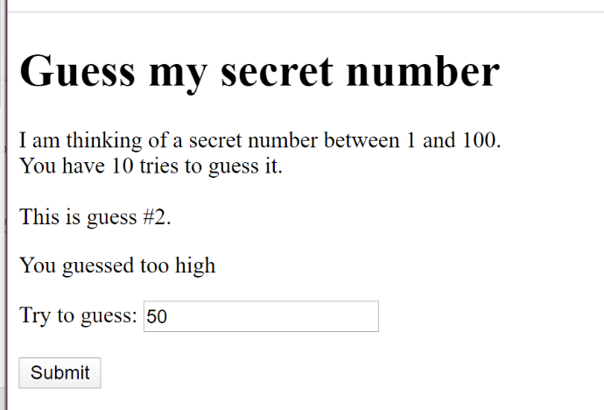
- Present a form to the user asking them to guess your secret number.
- Respond to the user whether the number is (1) too high, (2) too low or (3) just right i.e., they won!
- Count the number of guesses, and remember that number too. End the game if the player reaches the max number of guesses (max=10).

Task 2: Math Quiz
Student skill: same as Task 1.
This is another classic program which I use to learn a new language. Write a program to quiz the user on their math tables. You may hard code the math operation (addition, subtraction, or multiplication) – or you may have the user chose from a menu. Have the computer pick two numbers at random from a hardcoded range, and present the math problem to the user. The user must enter their answer into a field and submit the form. Your program will tell them if they got it correct or not. Loop over 10 problems and then present the user with their overall quiz score (e.g., 9/10 = 90%).
Hint: copy your program from Task 1 as your starting point. The MVC will be similar.
Requirements:
- Generate two random numbers (1 .. 10 or 20) and remember them throughout the game and per user.
- Present a math problem to the using those two numbers and a math operator such as addition, subtraction, or multiplication.
- Don’t display the answer, but have a form for the user to input/submit their answer
- Respond to the user whether their answer was correct or incorrect.
- Display the number problems the user has answered.
- After a max number (e.g., 10) tell the user that the game is over.
- When the game is over, display to the user their score – i.e., their percentage correct.
